**CSCE 5430 Deliverables 2**

**Software requirement specification**

**For**

**Online Pharmacy portal (Web Page)**

**Version 1.0 approved**

**Prepared by: Akella Soujanya**

**Akella Gayatri Sravani**

**Chahnitha Chandu**

**Nikhitanjali Dodla**

**University of North Texas**

**Date: October 2nd 2019**

**TABLE OF CONTENTS**

1. Introduction …….………………………………………………………………. 3
   1. Purpose …………………………………………………….………………. 3
   2. Document Conventions ...……………………….…………………. 3
   3. Intended audience and reading suggestions …….….…….. 4
   4. Project scope ……………………………………………………………… 4
   5. References ………………………………………………………………… 4
2. Overall Description ………………………………………………………….. 5
   1. Product perspective ……………………………………………………. 5
   2. Product features …………………………………………………………. 5
   3. User classes and characteristics ………………………………….. 6
   4. Operating environment ………………………………………………. 6
   5. Design and implementation Constraints ……………………… 6
   6. User Documentation …………………………………………………… 7
   7. Assumptions and Dependencies ………………………………….. 7
3. System Features …………………………………………………………………. 8
4. External Interface Requirements ………………………………………… 11
   1. User Interfaces …………………………………………………………….. 11
   2. Hardware Interfaces …………………………………………………….. 13
   3. Software Interfaces ………………………………………………………. 13
   4. Communication Interfaces ……………………………………………. 13
5. Other Nonfunctional Requirements …………………………………….. 14
   1. Performances requirements …………………………………………. 14
   2. Safety requirements ……………………………………………………… 14
   3. Security requirements …………………………………………………… 14
   4. Software Quality Attributes ………………………………………….. 14
6. Other Requirements ……………………………………………………………. 15
7. Plan for Project Development Phases ………………………………….. 16
8. **Introduction**
   1. **Purpose**

The idea of this web page is that, medicines are a necessity that must always be available to every person irrespective of whether or not they can travel. The only way that can be possible is that if there is a way to do so online. So, we are attempting to facilitate our customers with an online portal through where they can order their regular medicines using a prescription and have them delivered to their doorstep within no time.

The second reason for creating this is to have a platform where there can be lawful trade of drugs and restricted substances. In many countries pharmacists are neither aware nor bother to follow certain laws regarding drug sale. So, people can obtain any drugs without any restrictions. In some cases, these restricted drugs are sold over the counter. So, the customers are not even aware that they are getting involved in some crime.

On this pharmacy Portal, we are attempting to enforce all these laws and have strict policies regarding drug sale.

**1.2. Document Conventions:**

Font: Calibri (body)

Size: Text and subheadings (12)

Size: Headings (14)

The SRS document contains detailed information about the software and hardware requirements of our project. We have also discussed in detail, the project plan and other exceptions taken into considerations, such as assumptions made.

Full forms used in the document:

DB : Database

NPI : National Provider Identifier

**1.3. Intended Audience and Reading Suggestions:**

This document is intended majorly for the developers, software engineers and testers. The document covers information about all the functional and non-functional requirements of the web-pharmacy portal. There is a bit of something for everyone in it! Any user who might want to use it can see the hardware requirements for the webpage. Any future developer who wants to develop the page further can see the current features of the webpage and how they were developed, so they can start from there. The testers will get to know all the different aspects of the software that they are needed to test. Hence the document is a all-in-one guide to the pharmacy portal’s specifications. The document begins with a detailed description of its purpose and moving ahead, we discuss its software, hardware and communication specifications. Next up, we describe the different pages in the webpage and their functionalities. We also discuss the various classes involved and the operating environment. We have also provided a briefing of the constraints on which the web page is based on. There are certain assumptions that are made with the development of this page. They are also mentioned. Finally, we end with the security requirements of the web page.

**1.4. Project Scope**

The software is a web based pharmacy portal intended for allowing customers to buy drugs and other related products online. Now-a-days everyone is busy with their own lives and jobs. People hardly have time for family, let alone time to do things for them. So, going to a pharmacy store to buy medicines is a luxury they can’t afford. Also, there are people who live alone and are too weak to shop for things themselves. For those people, we have introduced an online portal, where customers can order medicines online. Also, there have been reports of illegal medicine trade that has happened in various places around the globe. Many Americans take multiple medications without fully understanding their benefits and risks. Unfortunately, over 1.5 million preventable hospitalizations occur each year because a medication is not taken properly. Medication reviews help empower people to better understand what they are taking, what to look out for, and when to seek help. We intend to fight that as well. We have a professional pharmacist to prescribe any over-the-counter medicines to our customers. We are like any other selling organization. We encourage people to take faster premium delivery options to be able to get their medicines in time. We offer a promotional discount to ay first time user to increase our reach among people. We provide generic drug options, which make the drugs cheaper but equally effective.

**1.5. References**

1. <https://www.fda.gov/drugs/questions-answers/generic-drugs-questions-answers>
2. <https://sites.utexas.edu/pc-knowyourmed/>
3. <https://www.rpharms.com/recognition/setting-professional-standards/safe-and-secure-handling-of-medicines/professional-guidance-on-the-safe-and-secure-handling-of-medicines>
4. <https://www.rte.ie/news/health/2018/1023/1006079-illegal-medicines/>
5. **Overall Description**
   1. **Product Perspective**

The product being designed and described in the SRS is kind of a follow-on member of a product family. It is similar to the family of e-commerce websites. In general, e-commerce websites allow shopping with pretty much everything. They are usually meant for stuff like technology, home appliances, cosmetics, etc. There are other websites which are meant only for the specific kinds of products, such as e-commerce for fashion, those for hardware appliances, e-commerce for a specific brand products etc.

Now, we are designing a website specifically for medicines and legal trade of drugs. There are also similar websites in other countries like India, Japan, etc. We are now implementing one that is intended for use in Texas.

The ER-diagram showing the basic operation of the system is given below.

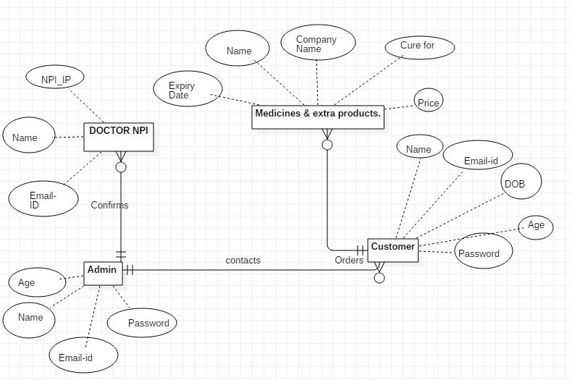

**Figure 1: ER Diagram describing the system**

This ER (enterprise relationship) diagram describes the basic structure of how the system is going to be built. The system consists of four entities. The relation they share and interaction is shown in the diagram above.

* 1. **Product Features**

The features of the software involve:

* Cart option for Customers
* Easy profile updates
* Over-the-counter Medicines for simple problems
* Separate accounts for admin and customer
* Admin can view/update and modify DB very easily.
* Admin has liberty to accept or reject orders
* Easy registration for new users
  1. **User classes and Characteristics**

As per our anticipation, we expect the webpage to be mostly used by people with chronic diseases that need constant medication or by people who might otherwise have to depend on someone else to do his/her shopping for them.

We expect people with chronic diseases because; these are the ones that must take some medicine every day. So for them even the pharmacy is like a mandatory trip just like groceries shopping. Also, in most cases, their prescriptions don’t change for months together. For that reason, getting those drugs online would make it so much easier for them.

Next, we expect people like really old people who will need a helper to get through their day to use this service. Anyone can use a system or their mobile on their own. So, it is a very comfortable option for them to get their medicines online. Even if we consider the fact that old people might not be very tech-savvy, anyone related to them can do it for them.

I don’t think the families who have at least one person who is not working or has someone to do their things for them might find the web-service very useful. So, they are not really our primary customers. Also, healthy people who might only need drugs for occasional sickness might find the pharmacy portal very useful. I mean I wouldn’t want to sit around waiting for a medicine for a full day before I heal if my problem is just common cold or a head-ache.

**2.4 Operating Environment**

Operating environment for this online Pharmacy portal is as follows –

* Single dedicated Database
* Single server
* Operating System – Windows
* Database – MySQL
* Platform being developed in – PhP, Bootstrap, CSS

**2.5 Design and Implementation Constraints**

* The database will be implemented using a centralized database schema
* Because the medicines should not be delivered after its expiry date, we should guarantee that the medicines be delivered within 24 hours and hence the business is local to a single city/town.
* Based on the Bootstrap version used the website will be operational in the latest version of chrome only.
* The mailing feature whenever an order is placed will be done using the SMTP protocol.

**2.6 User Documentation**

* A complete document that includes all the system features and all ER diagrams that describe the architecture of how the website was built.
* Complete code for various elements in the project
* The test case scenarios for different functions in the website i.e., use case diagrams
* Minutes of meeting throughout the project
* List of all the images used in the project
* A list of references used in doing this project
* A Readme file that describes where to find the respective files in the GitHub folder and how to use the website in case we need any extra software or any more instructions

**2.7 Assumptions and Dependencies**

We have a made a few assumptions for this system, which we assume to be true in all cases.

* We assume that it is always be possible to deliver products within one day.
* We assume that we have details all doctors in Texas in our database. So, anyone not in our database is not a real doctor.
* Functionally, we expect to be able to store all required data, develop the pages and host the project within the memory we have mentioned.
* We believe that we will be able to complete all the tasks within the planned time.

There are certain dependencies to the webpage:

* The page is dependent on PayPal for any online payments. If ever paypal is down, the page will also fail.
* The entire page is dependent on a single admin. So we depend on him/her to accept or reject orders, maintain database, delete expired medicines in a timely manner, etc.
* The efficiency of the database is dependent on the Xampp server.

1. **System Features**

This section describes the different features implemented to be able to properly perform all the functions in this pharmacy portal. The features are listed according to the different user classes they are present in and in the most probable chronological order that they are used while using the portal. We have only 2 main types of user classes and they are –

* Admin
* Customer

Each of these users have their specific functions and also some common functions. The system allows the creation of multiple customers, but a single admin user is created before deployment. There will be no more admins than the one created initially.

**3.1 ADMIN**

The admin is someone who manages the proper conduct of the website. Here we have assumed that a person is available at all or most of the times to manage some responsibilities like managing the orders of Non-OTC medicines. The admin has the following features when logged into his account to be able to carry out his functions properly.

**1. View Database**

**REQ-1**: In this section the admin should be able to view all the medicines available in the database. It will be displayed in the alphabetical order. Also, all the details about the medicines like the Name of the medicine, Cost per unit, Expiry Date, OTC Flag (flag that indicates whether it is an over the counter medicine or not) and available quantity should be shown on this page

**REQ-2**: There will be options to update the medicine’s details on this page. The admin will be able to update the quantity of these medicines in case a new stock has arrived or if any medicines are not available. He/ She can make changes to the price also if there are any.

**REQ-3**: The admin will also be able to create new medicines. But all the necessary details that are displayed need to be entered else, an error message will be displayed when the admin user tries to save the changes. Even when the admin tries to create a medicine that is already existing the system will display an error message for Duplicate medicines. No 2 medicines can have the same name.

**2. Accept / Decline Non-OTC Orders**

**REQ-1**: The admin will receive a message whenever a Non-OTC medicine is ordered. This will allow the admin to check for the uploaded prescription and see whether it’s a valid prescription or any random file.

**REQ-2:** When the admin declines an order, he will be able to enter comments on why the order is getting declined. The status of the order will be changed to decline in the table upon this action and hence the same is reflected in the user’s account too along with comments.

1. **Update Profile Information**

**REQ-1:** The admin user will be able to view all his personal details that he entered at the time of account creation will be seen here. The fields include his First name, Last name, Date of Birth, Address, Email ID, phone number and Password (not in plain text). He can edit any of these and save the changes. However, the username cannot be changed i.e., the username will usually be his/her email-ID. In case the email ID changes the username will still be same.

If the user tries to save the changes without entering any of the above mandatory fields an error message will be displayed. Even if any of the information entered is in the wrong format an error will be displayed and the data is not saved.

**3.2 CUSTOMER**

There can be multiple customers in the system, and we can create as many as we want as long as the email ID, the first name or Last name are all unique. The customer should be able to easily add any products of his choice to the cart and place an order as long as he has all the necessary information. For the proper functioning of this portal from the customer’s point of view the following functional requirements need to be achieved.

1. **Search Medicines**

**REQ-1:** The user should be able to search for desired medicines using either the name of the medicine or the health problem.

**REQ-2:** In case there are no medicines available for that problem then it should display a message saying there are no medicines available. Otherwise if the medicines are simply out of stock, it means that a record with that medicine name is present in the DB but the quantity is 0. In such cases, the medicine will be displayed along with the message out of stock.

1. **Add Medicines to Cart**

**REQ-1:** Once the customer finds products of his choice, he should be able to add them to cart. Any number of products can be added to the cart after viewing all the details. The number of items in the cart can be viewed only after we click on the cart button.

1. **View and Checkout**

**REQ-1:** Once the user adds all that he/she needs into the cart they can view the cart and make any changes by removing the products from the cart. Any changes made will be reflected in the cart. The user will be able to see basic fare details of each product and the total amount to be paid also.

**REQ-2:** Once, the user clicks on the checkout, if there are any Non-OTC medicines some more mandatory fields need to be updated. Otherwise, the user will have to first fill in the address details and then we will have 2 options for Payment – PayPal or COD. The user has to choose one of these. We will use the PayPal in the sandbox mode for this project.

**REQ-3:** If the user selects the PayPal option and makes the payment then it will notify as soon as the payment is successful. By the end of this process we will also be generating a random 6-digit number which will be the order number for that particular order. Facility to update the tracking number as soon as the order is shipped will be provided. However, this might be out of the scope of this project.

1. **Buying Non-OTC medicines**

**REQ-1:** After clicking on Check out button, if any medicines in the cart are Non-OTC then the user will have to upload a prescription, enter the doctor’s NPI and his email ID. We will have a list of doctors’ list in our database with this information and this project will have scope to buy medicines prescribed by these doctors only.

**REQ-2:** After proper details are entered the order is placed on hold for the admin to approve and once that is done these orders are placed. Orders with non-OTC meds can only be bought through COD

1. **View and Update Profile Information**

**REQ-1:** The users can view all their personal information in this tab and also edit any information. This is similar to the profile page of an admin user.

**REQ-2:** If the user does not enter any mandatory fields or enters them in the wrong format validations will be included to display the corresponding error messages.

**3.3 LOGIN / REGISTRATION MODULE**

1. **New Customer Registration**

**REQ-1:** When a new user wants to register, he or she can register by giving all the necessary details as prompted in the registration page. We will not allow anyone who is less than 18 years of age to create an account. Once all the necessary details are entered an account is created and the database is updated.

1. **User or Admin Login**

**REQ-1:** Both the users and admin will use the same login page. There will be validations in place to make sure that their respective home pages will be opened based on the username and password.

**REQ-2:** In case of the wrong username or password an error message will be displayed. If a user forgets the username/password, he or she has to contact the support as there is no forgot password option. Normal users can’t attempt admin login.

Another important feature in this project is a single Database that manages all the data i.e., data is not distributed to many places. Delivering medicines to different cities does not seem a very viable option as it will take a long time and medicines need to be delivered faster. For this reason, we believe that a single database and a single server will be sufficient to host this website.

**4. External Interface Requirements**

**4.1 User Interfaces:**

Our website is not a mobile application and it only works on Computer systems or laptops. Below is the description of User Interfaces that the user will encounter while using our website:

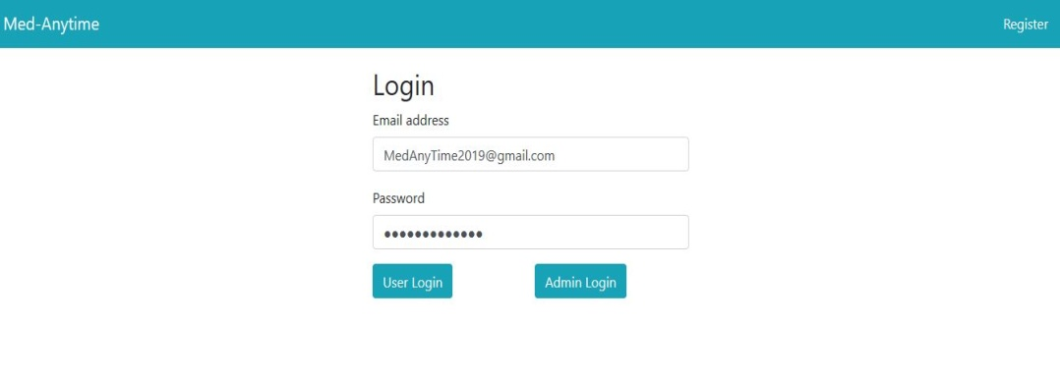

The **Home page** consists of two options register and login. A new user can register by providing all details as mentioned on the registration page. Registration will not be complete if any of be mandatory fields are left empty or incomplete. Registered users can directly use the login option by entering appropriate details where needed. An error message will be displayed if inappropriate details are given.

Next, on successful login, we enter the admin page or user page depending on which option is selected in the login page. The admin page and user page look sort of similar except for a few differences like functionality of navigation bar and search bar, and few other options.

The user page looks as shown in the below screenshot.

It shows options to view cart and update profile.

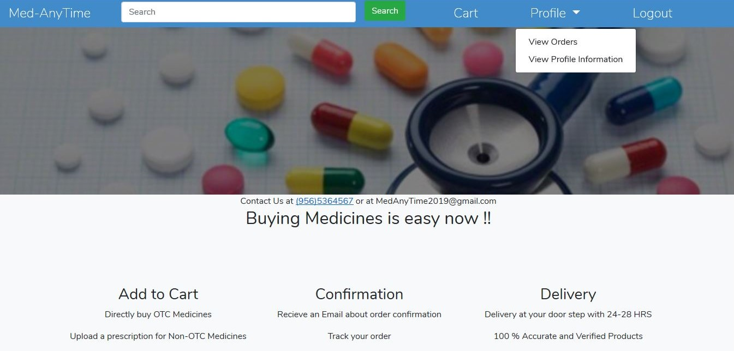

Next, the registration page, which will basically be a web form where the user has to enter all the necessary details and then his account will be created. The registration page looks as shown below.

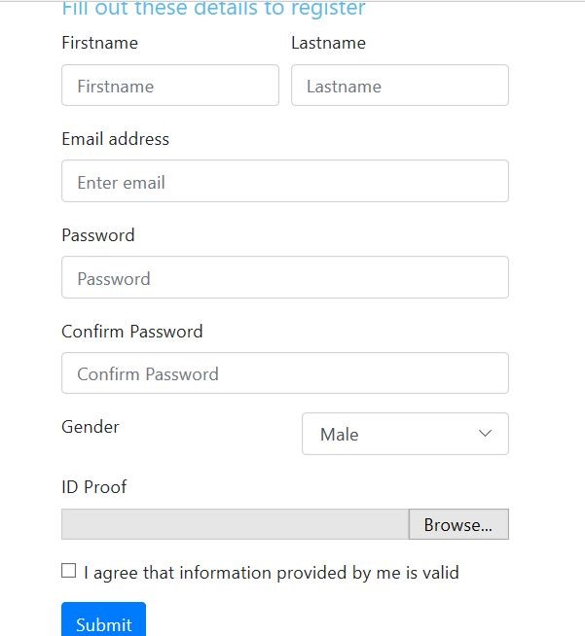

All the above-mentioned screenshots are the pages that we have developed in our project until now. This is only a sample development of our UI, substantial changes will be done to this further so that user can interact with our system effectively.

**4.2. Hardware Interfaces:**

**Processor**              - Intel Core i5 or more

**Processor Speed**   -2.5 GHz (Faster is better).

**RAM**                     -8 Gb or more

**Hard Drive**            -1TB

As this website runs over the internet, we need an Ethernet connection (LAN) OR a wireless adapter (Wi-Fi) to the computer system. There is hardware components present to communicate with.

**4.3 Software Interfaces:**

**Database**- MYSQL- All the data tables related to our website are created, Stored, and updated in MYSQL. All the changes that the user or admins make in their accounts are automatically reflected in the database.

**Operating System**- Windows 7 or more,

**Tools and Development Environment**- Visual Studio Code, XAMP. XAMP web server is used to host our website.

**Libraries/Framework**- Bootstrap

**Messages or data items:**

* Paypal messages/ notification
* UPS tracking notifications
* Email confirmations for all actions
* Doctor’s confirmation message for all non-otc orders.
* Admin communicates with users for various reasons.

The nature of the communication of software components is through the HTTP request and HTTP response over the internet using TCP connection. We haven’t taken the application programming interface exactly from any referred document. We have taken inspiration from [www.amazon.com](http://www.amazon.com).

**4.4 Communication Interfaces:**

Supported web browsers are Chrome and Firefox. The HTTP protocol is used for communication between client and server using a TCP connection. Email notifications can be sent to the customer through the SMTP protocol. Our system is securely based on the constraints that we employ to the user while interacting with the website. If the time permits, we are also planning to implement the HTTPS (HTTP + SSL) for our system.

**5. Non Functional Requirements**

**5.1 Performance Requirements:**

If the mentioned hardware requirements are met by the customer then there should be no issues in the performance of our website. Roughly, it should take 2 seconds for every action-response of the system. User and admin can login simultaneously and also multiple users can access the website at a time. No restrictions for the number of orders in the shopping cart. It takes less than 2 minutes to deliver Email notifications to the customers.

**5.2 Safety Requirements:**

All the products that we sell on our website are updated regularly and 100% genuine. We ensure to follow all the storage requirements of the medicines specified by the manufacturer. Customers need not worry about safety requirements.

**5.3 Security Requirements:**

Our website can be accessed 24/7 so it fulfills the availability constraint. We encourage using a strong password for all accounts, to ensure confidentiality. N user is allowed to use the website withput a proper account, to ensure integrity. All CIA triads requirements are met which safeguards the system. Also, the admin will manually verify the ID proof and other registration details, only accept the email with the Gmail extension. Forgot password functionality is not implemented directly on our website they need to approach admin to make that change. All these conditions ensure security and we are also planning to implement HTTPS for our system.

**5. 4 Software Quality Attributes:**

**Usability:**This system is supported on a computer or a laptop. User Interface is pretty much easy to understand and use by the customers. No complexity involved in understanding the usage of options mentioned on our website.

**Reliability:**The system is reliable i.e. consistent in its performance and trustworthy in the products being sold. Payment processing is done by one of the prominent gateway PayPal so there should no concerns related to trust or security of the transactions.

**Correctness:**Rigorous or in-depth testing will be done by us before deploying our website. So, we expect the system to be pretty reliable, and correct.

1. **Other Requirements**

**Appendix A: Glossary**

The whole SRS document is written in very simple words. So, all the words in this document are laymen terms.

**Appendix B: Analysis Model**

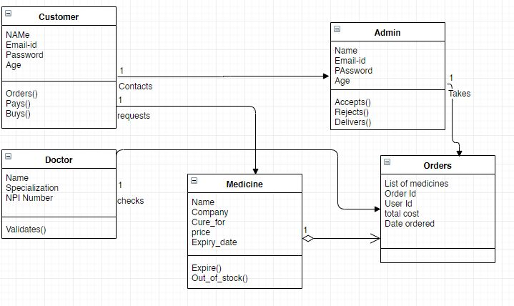

**CLASS DIAGRAM**

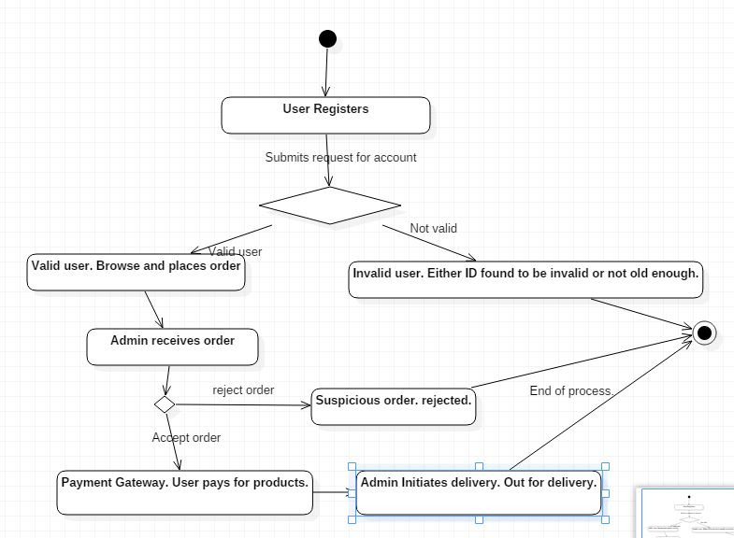

**STATE TRANSITION DIAGRAM**

**Appendic C: Issues List**

Currently, we have not completely developed the webpage fully yet. As of now we do not expect any issues. But, if they do occur, we will deal with them as best possible at that time.

1. **Plan for Project Development Phases**

**Implementation Plan:**

Based on the criticality and dependencies of each task on one another we have developed the following implementation plan including 3 phases for the development of this project.

**Phase 1**: The development of all the user interfaces involved and their interconnections will be done in the first phase. This will ensure that we are all on a single page about what all features will be there in the project. Parsing from one page to another and hosting all of these using Xampp will be done. All the fields and buttons would be working but no data will still be saved as the database connections would not be setup.

**Phase 2**: In this phase, we will each one of us share duties to complete the data connection setup for each page and write the necessary code in PhP for that and also setup the PayPal connection. Along with these, one of us will also do the necessary coding for enabling the checking of prescriptions and cross-checking of NPI number and Mail_ID from the doctor's NPI table by the admin.

**Phase 3**: The last phase will have the e-mail integration as soon as an order is created to the user and rigorous testing will be performed on all the modules separately to make sure the website is error free. Any features that were not incorporated or need changes will be taken care of in this phase.